Rational Numbers
What is a Rational Number?
- = A number that can be written in the form _______________________.
  - Examples: ________ ________ ________ _________
  - Also examples: ________ ____________ _________ _________
  - Are integers rational numbers??
Fractions
- One type of rational number is a fraction
- Fraction= A number written in the form a/b, _______________________________
- Fractions can be
  - Regular: $\frac{1}{2}$
  - ________ _______: $\frac{9}{2}$
  - ________________: 4 $\frac{1}{2}$
Plotting Fractions
- Where would the following go on the number line?
1/2 3/2 1/3 -4/5 -7/3
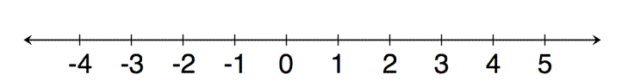
- You Try!
- Plot the following numbers on a number line:
5/7 -4/3 2/1 -3/-2
Adding and Subtracting Fractions
- The _________________________ (bottom number) must be the same before fractions can be added or subtracted
  - Example $\frac{7}{3}$ - $\frac{2}{3}$ = ____
- If they are not the same, we have to find the ____________________________________
  - Example: $\frac{2}{3}$ + $\frac{2}{5}$ = $\frac{10}{15}$ + $\frac{6}{15}$ = $\frac{16}{15}$

What if the fractions are negative?
- Adding and subtracting negative fractions use the same rules as adding and subtracting integers
  - Example: 3/4 + (-9/4) = -6/4

  - Example: (-3/2) – (8/3) = (-9/6) – (16/6) = __________

You Try!
- -6/9 + (-4/9) | - 4/5 – (-3/4)
- -7/2 – 5/2 | - 6 $\frac{2}{3}$ + (-3/5)
- -6 + (2/3)

